**Interview Scheduling Management System**

**Use Case Document**



|  |  |  |  |
| --- | --- | --- | --- |
|  | Prepared By / Last Updated By | Reviewed by | Approved By |
| Name | Prachi Kumari, Rohini Bansal, Pranay Chouhan | Mr. Abhinandan | Mrs. Shilpa Mahajan |
| Role | Team Member | Mentor | Academy Head |
| Signature |  |  |  |
| Date |  |  |  |

Table of Contents

1.0 Introduction 3

1.1 Purpose & Scope of the document 3

Intended Audience 3

1.2 Use case ‘User Registration’ 3

1.2.1 Use case attributes 3

1.2.2 Business Rules 4

1.2.3 UI Requirements 4

1.2.4 UI Field Validations 5

1.3 Use case ‘Add Candidate Requirements’ 5

1.3.1 Use case attributes 5

1.3.2 Business Rules 6

1.3.3 UI Requirements 6

1.3.3 UI Field Validations 6

1.4 Use case ‘Edit Candidate Requirements’ 7

1.4.1 Use case attributes 7

1.4.2 Business Rules 8

1.4.3 UI Requirements 8

1.4.4 UI Field Validations 9

1.5 Use case ‘Interview Schedule’ 7

1.5.1 Use case attributes 7

1.5.2 Business Rules 8

1.5.3 UI Requirements 8

1.5.4 UI Field Validations 9

1.6 Use case ‘Interview Observation’ 9

1.6.1 Use case attributes 9

1.6.2 Business Rules 10

1.6.3 UI Requirements 10

1.6.4 UI Field Validations 12

2.0 Database Design 18

2.1 Tables Structure 18

3.0 Data Flow Diagram 19

# Introduction

## Purpose & Scope of the document

This document is aimed at:

* Providing the necessary inputs to the detailed requirements gathering phase and further on for the SDLC processes.
* This document also serves to establish the traceability between the Business Objectives and the requirements identified in the proposed solution and how they satisfy the stated objectives.
* Provide expectation traceability in terms of the requirements and the user expectation
* Serves as a formal template for documenting the Business Requirements which also includes statutory and regulatory requirements.

The purpose of this document is to systematically capture the requirements of the project and the system to be developed. The document also captures the Functional requirements and serves as an input for the scope of project.

## Intended Audience

Each member of the project team:

1. Prachi- 768883
2. Rohini- 768893
3. Pranay- 768884

## Use case ‘User Registration’

### Use case attributes

**Use Case Description:**

Used to register the details of a candidate into the system. The system should calculate the rank for each candidate and store the details in the system.

**Scope:**

* User registration

**Actors:**

* User – the operator

**Trigger:**

Click ‘Register’ button in the ‘User Registration’ page

**Pre-Condition:**

User being able to access the homepage & get redirected to the ‘User Registration’ page upon click of ‘Register’ link on the login page.

**Post Condition:**

User is in the registration page & submit details

**Flow of Events:**

User at homepage 🡪 Click ‘User Registration’ link 🡪 User at Registration page 🡪 Click ‘Register’ link 🡪 User is in the registration page 🡪 User details are submitted and added onto the database.

**Primary Scenario:**

A new user – is able to click ‘Register’ link and able to provide his details and get registered in the system.

### Business Rules

Business rules should be defined using the following attributes: -

* When the user clicks on the register link, it should re-direct to registration form.
  + - User needs to fill some of the basic attributes/fields as mentioned below in requirement: First Name, Last Name, Age, Gender, Contact Number.

Email id, Password, Qualification, Candidate, Hirer company name

* + - Clicking ‘Register’ should validate the datatype constraints for each field
* Post-successful field level validation, save the information in the database
* Upon saving the information in the database, display the message ‘Your have successfully registered’.

### UI Requirements

Here is a prototype on how the login page should look like.

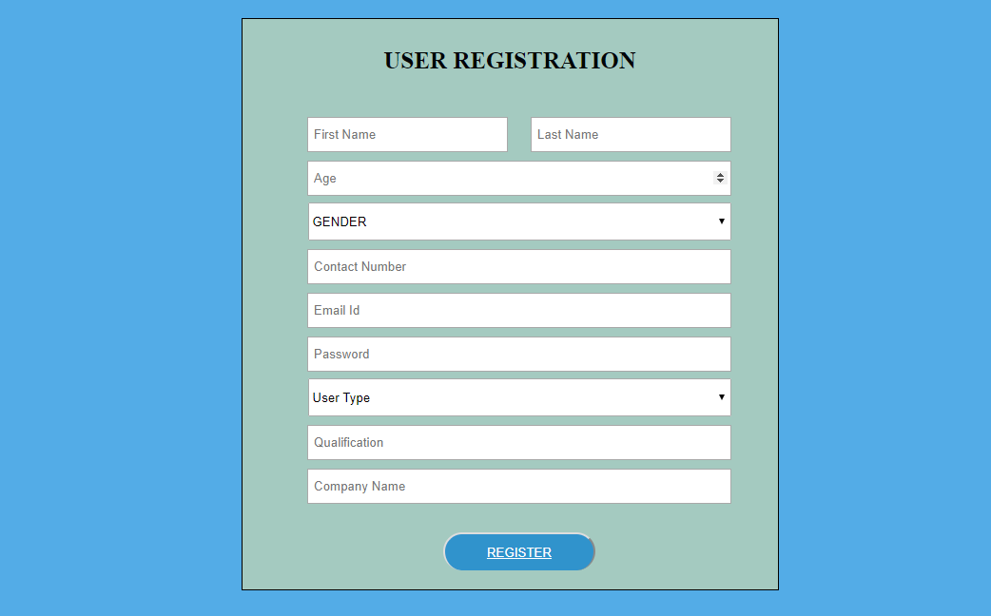

### UI Field Validations

Please refer to the below requirements for field level validations:

* Phone Number must be of 10 digits’ length.
* Age should be 2-digit numeric value.
* First Name, Last Name should contain only alphabets.
* Gender should be chosen from the dropdown options.

## Use case ‘Add Candidate Requirements’

### Use case attributes

**Use Case Description:**

System should display all the necessary fields in the screen- Employee ID, Domain, Required Vacancies, Closing Date, Priority, Minimum Experience, Submit Button

**Scope:**

* Adding candidate requirements

**Actors:**

User – admin

**Trigger:**

On clicking submit the system needs to determine the mode of interview and add a new job requirement to the system.

**Pre-Condition:**

User being able to access the Add candidate requirement page.

**Post Condition:**

User is in the Add candidate requirement Page.

On clicking submit the system needs to determine the mode of interview and add a new job requirement to the system.

**Flow of Events:**

User at homepage 🡪 Click ‘User Registration’ link 🡪 User at Registration page 🡪 Key in ‘Username’ & ‘Password’ field 🡪 User credentials are validated 🡪 Add candidate Requirement page is displayed-> Click register after adding the candidate requirements-> Add the data to database.

**Primary Scenario:**

A registered user must be adding all the necessary fields in the screen- Employee ID, Domain, Required Vacancies , Closing Date, Priority, Minimum Experience, Submit Button .

### Business Rules

Business rules should be defined using the following attributes: -

A registered user is able to– Click ‘User Registration’ link 🡪 User at Registration page 🡪 Key in ‘Username’ & ‘Password’ field 🡪 User credentials are validated 🡪 Add candidate Requirement page is displayed-> Click register after adding the candidate requirements-> Add the data to database.

### UI Requirements

Here is a prototype on how the Adding Candidate Requirements page should look like.

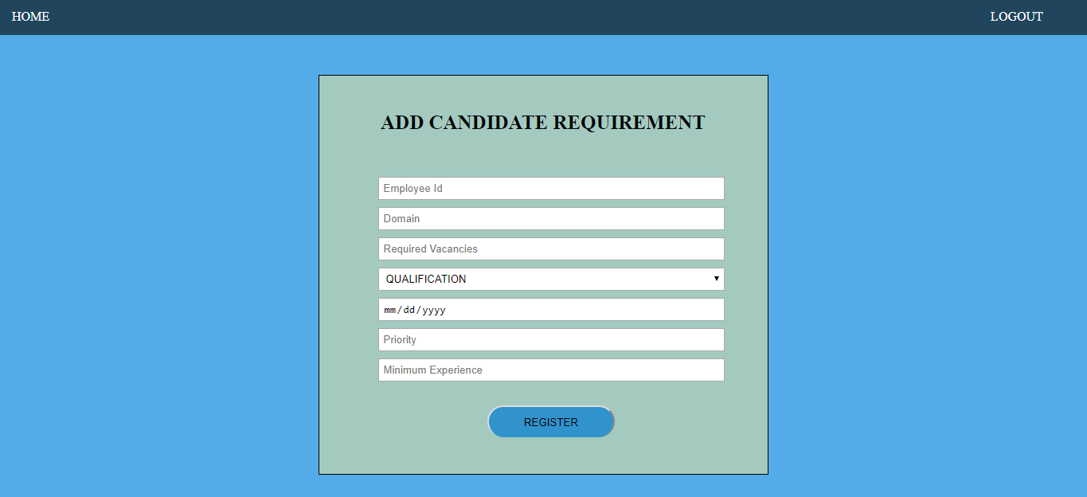

## Use case ‘Edit Candidate Requirements’

### Use case attributes

**Use Case Description:**

This use case deals with the editing of candidate details. The ‘admin-HR’ here shall be the operator of the system and will be keying in the editing details.

**Scope:**

* Edit Candidate Requirement

**Actors:**

* Admin – the operator

**Trigger:**

* Admin should get redirected to the ‘Edit Candidate Requirement’ page upon clicking on the ‘Edit Candidate Requirement’ link.

**Pre-Condition:**

* Admin should be able to get redirected to the ‘Edit Candidate Requirement’ page upon clicking the ‘Edit Candidate Requirement’ link on the admin page.

**Post Condition:**

Admin is in the edit page & submit candidate details.

**Flow of Events:**

A registered user is able to– Click ‘User Registration’ link 🡪 User at Registration page 🡪 Key in ‘Username’ & ‘Password’ field 🡪 User credentials are validated 🡪 Add candidate Requirement page is displayed-> Click register after adding the candidate requirements->After adding details, admin-HR will edit the details if required-> And submit the details-> details are added to the database.

**Primary Scenario:**

* Admin should get redirected to the ‘Edit Candidate Requirement’ page upon clicking on the ‘Edit Candidate Requirement’ link.

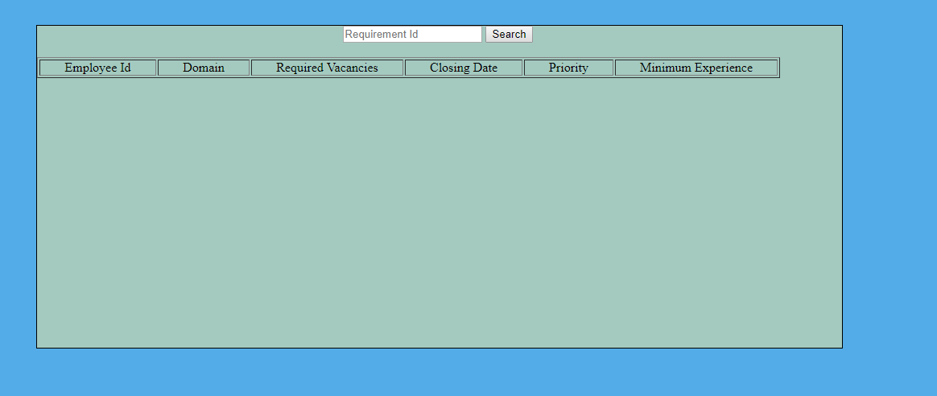

### Business Rules

Business rules should be defined using the following attributes: -

* When the admin clicks on the vendor registration link, it should re-direct to vendor registration form.
  + - User needs to fill some of the basic attributes/fields as mentioned below in requirement: Vendor name, Company Reg. No , Address, Country, State, E-Mail, Contact Number, Website, Certificate Issued date, Certificate Validity date, Year of, Establishment, Payment Gateway;
* Clicking ‘Register’ should validate the datatype constraints for each field
* Post-successful field level validation, save the information in the database
* Upon saving the information in the database, display the message ‘Your have successfully registered’.

### UI Requirements

Here is a prototype on how the admin page should look like.

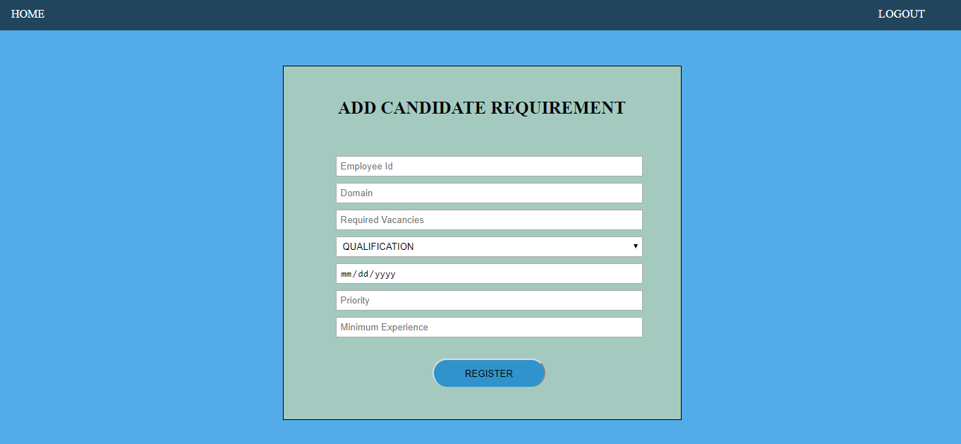

### UI Field Validations

Please refer to the below requirements for field level validations:

* All fields are mandatory.
* The Email ID format must be checked.
* Website should be alphanumeric of 15 length.
* Contact Number must be of 10 digits’ length.
* First Name, Last Name should contain only alphabets.
* Qualification should be chosen from the dropdown options.

## Use case ‘Interview Schedule’

### Use case attributes

**Use Case Description:**

Used by HR to schedule the interviews for the candidates based on their profile and job requirement

**Scope:**

* Schedule Interview

**Actors:**

* Admin – the operator

**Trigger:**

Click ‘Submit’ after scheduling interview of a student based on their rank.

**Pre-Condition:**

Used by HR to schedule the interviews for the candidates based on their profile and job requirement.(Based on their Rank)

**Post Condition:**

Interview is scheduled for a student based on his rank and the details are stored in the database accordingly after clicking on ‘submit’ button.

**Flow of Events:**

A registered user is able to– Click ‘User Registration’ link 🡪 User at Registration page 🡪 Key in ‘Username’ & ‘Password’ field 🡪 User credentials are validated 🡪 Add candidate Requirement page is displayed-> Click register after adding the candidate requirements->After adding details, admin-HR will edit the details if required-> And submit the details-> details are added to the database-> Now the interview is scheduled for the students based on their ranks and their profiles-> Details are added to the database after the clicking on ‘submit’ button.

**Primary Scenario:**

The admin-HR will schedule an interview for the student based on his rank and his profile and venue is allocated by the HR.

### Business Rules

Business rules should be defined using the following attributes: -

* When Admin clicks on schedule interview link, Then, based on the ranks, qualification and requirement profile of student, interview is scheduled.
  + - The admin needs to fill details such as requirement ID, Qualification of a student, rank of a student and candidate name in the form.
* The HR will also allocate the venue for interview based on the business requirement.
* Post- successful filling of all details, Admin will submit the details to the database and the interview is scheduled for them.
* And all the details are continuously saving to the database too.

### UI Requirements

Here is a prototype on how the ‘Interview Schedule” page should look like.

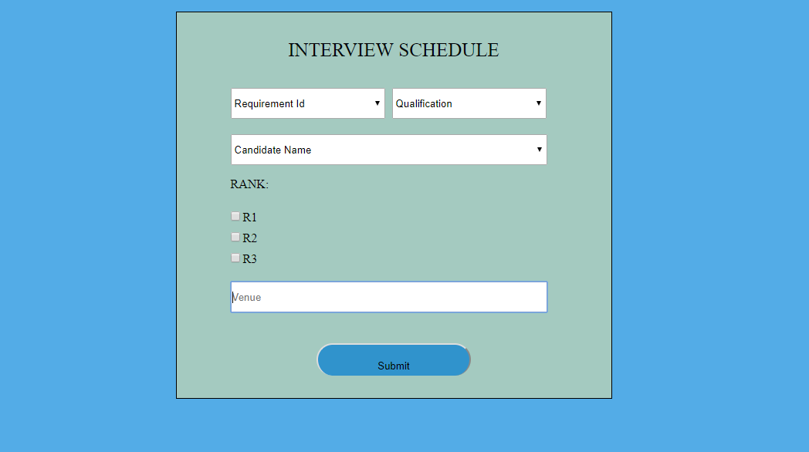

### UI Field Validations

Please refer to the below requirements for field level validations:

* All fields are mandatory.
* Candidate Name, Requirement ID and Qualifications must be selected from the drop down list.
* Rank should be according to the credibility of a student.
* After submitting the details, the data is saved into database and the interview is scheduled.

## Use case ‘Interview Observations’

### Use case attributes

**Use Case Description:**

Used by HR executive to register the details of candidate Interview Observation into the system. The HR executive should have the details of the Interview observations to be entered into the system.

**Scope:**

Observation of interview

**Actors:**

* Admin-HR – the operator

**Trigger:**

Click ‘submit’ button after filling all the candidate details by admin for obsewrving the interview of a candidate.

**Pre-Condition:**

Used by HR to observe the interview of a candidate based on the performance of a candidate.

**Post Condition:**

User can observe his/her interview after clicking ‘submit’ button by the HR after filling the requisite details.

**Flow of Events:**

A registered user is able to– Click ‘User Registration’ link 🡪 User at Registration page 🡪 Key in ‘Username’ & ‘Password’ field 🡪 User credentials are validated 🡪 Add candidate Requirement page is displayed-> Click register after adding the candidate requirements->After adding details, admin-HR will edit the details if required-> And submit the details-> details are added to the database-> Now the interview is scheduled for the students based on their ranks and their profiles-> Details are added to the database after the clicking on ‘submit’ button

->Interview observation will be done by selected candidates with the help of HR by submitting the requisite details in the interview observation form based on the performance of a candidate-> Finally The user can observe his interview.

**Primary Scenario:**

A user Is able to observe his interview with help of HR by submitting the requisite details in the interview observation form based on the performance of a candidate.

### Business Rules

Business rules should be defined using the following attributes: -

* The HR will click on the interview Observation link and get onto that form.
* After that HR will fill all the requisite details such as requirement ID, candidate name and marks of a candidate.
* Based on the performance of a candidate, he/she will be able to observe their interview.
* Finally, after observing the interview The whole process of Interview Scheduling management is completed.

### UI Requirements

Here is a prototype of how Interview Observation form will look like:

